**You sit on a Throne of Lies**

**RULES:** Practical Shooting Handbook, Latest Edition **COURSE DESIGNER:** Matt Gallant

|  |  |
| --- | --- |
| **START POSITION:** Standing anywhere outside the shooting area with weak hand touching any wall.  Handgun is loaded and holstered.  **PCC START:** Same and handgun with muzzle pointed downrange. | |
| **STAGE PROCEDURE**  On start signal engage targets as they become visible, from within the shooting area. | **SCORING**  **SCORING:** Comstock, 25 rounds, 125 points  **TARGETS:** 11 USPSA, 1 popper and 2 mini poppers  **SCORED HITS:** 2Best per USPSA, Steel KD = 1A  **START-STOP:** Audible - Last shot  **PENALTIES:** Per current USPSA rulebook |

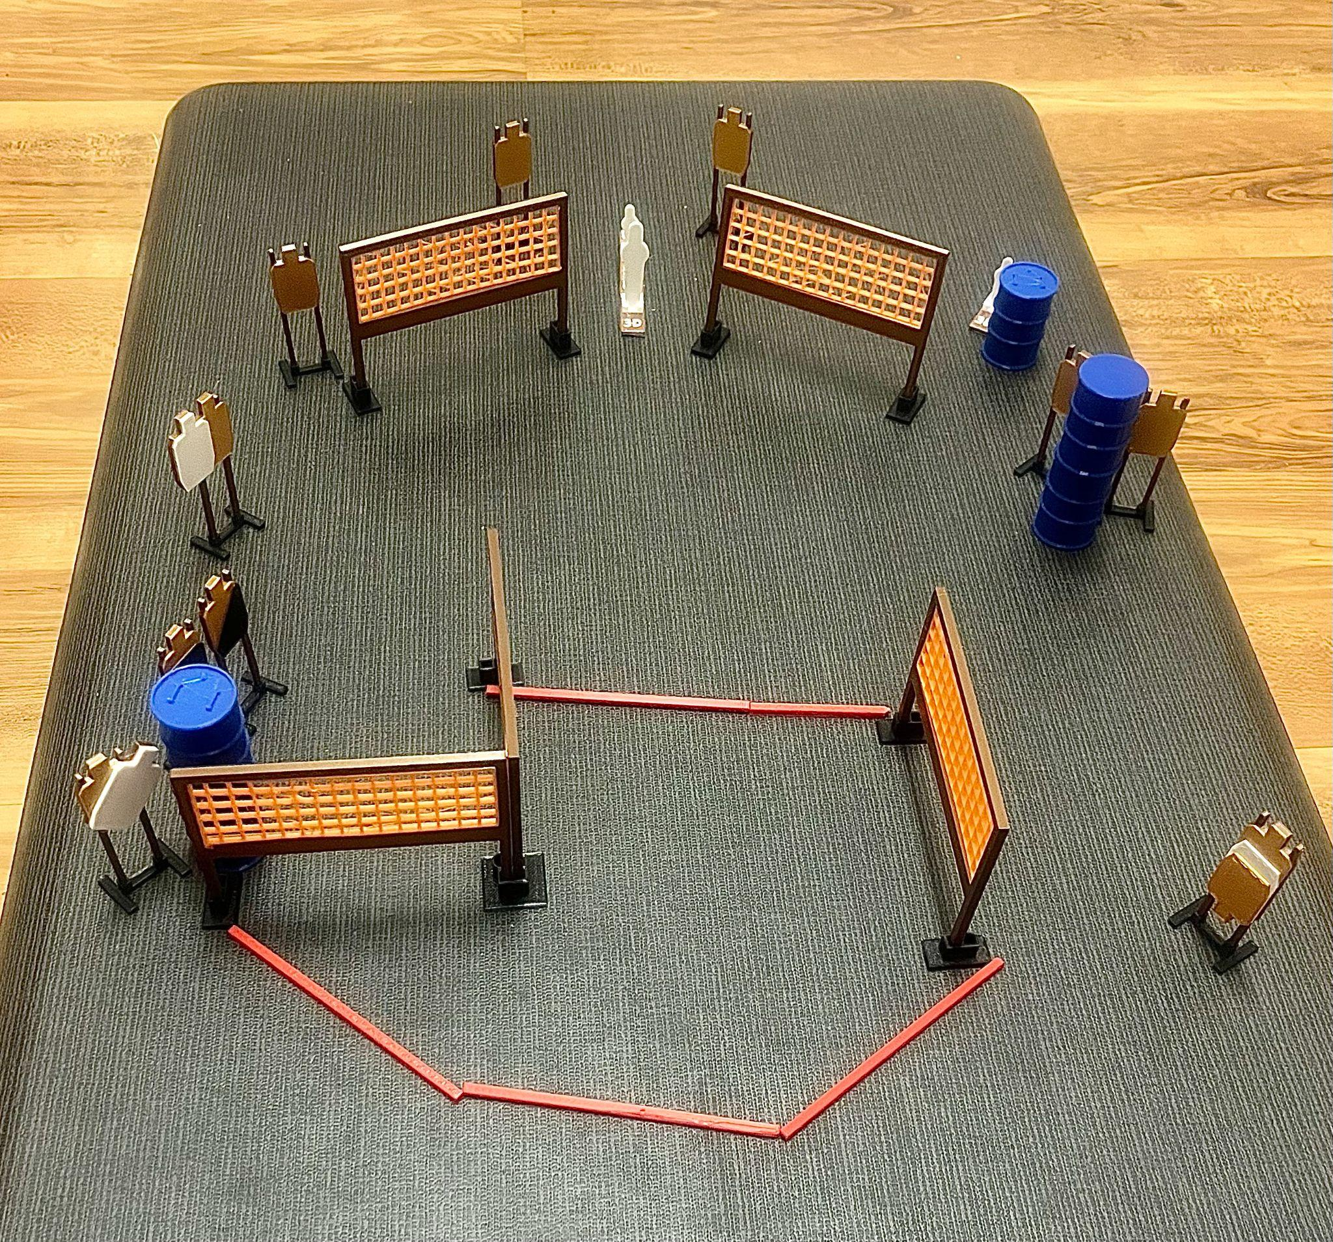

|  |  |  |
| --- | --- | --- |
| **SETUP NOTES**: |  | **RO NOTES**: |